The functionalities is the same like JSP and JDBC practical. It only changes to using wsdl where it is a web services

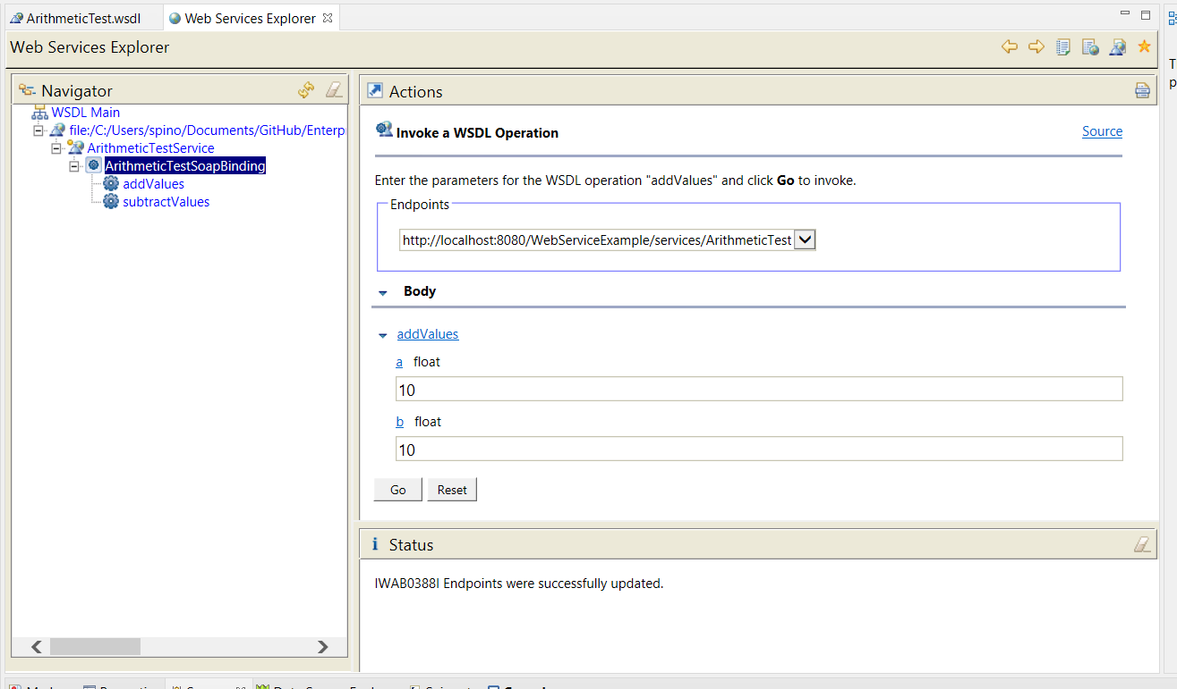

This show to invoke wsdl operation by adding the value and creatin endpoints. If we press go, the answer will be shown

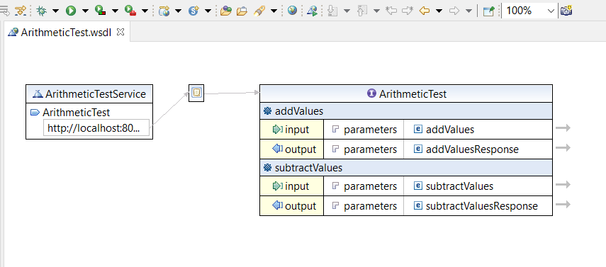

This is the design of the arithmeticTest . show that can add values and subtract values with a parameters